Competitive spirit of the west combined with Collaborative eastern values. I would wish to work at the synergy between tech and business.
Information MANAGEMENT
IM relates to understanding the information required to run a business; IT is the structure that supports it. Management of Technology for business, society and social good for overall good of India.
We are living now at industrial revolution 4.0, thus future is data. Whole lot devices collect data. This data is processed to get insights. And insights lead to wisdom and knowledge and better decision making.

BASKETBALL:
I liked playing basketball. But after my injury, I didn’t feel like watching competitive basketball much. But last I saw, I really admired Lebron James.
Indian in NBA:
Sim Bhullar (Canadian of Indian Descent)
Satnam Singh Bhamara (Dallas Mavericks)
LEBRON JAMES (LA lakers, Cavaliers, Heats)-
- Very consistent record of appearing for the NBA finals.
- At the age of 37 too, and for the last couple of games he has been averaging around 35 points, and putting up stats that are really unbelievable for a player who is going to touch 40.
- He can play any position. Power forward position, but he is excellent at point guard too. Also can play centre. He can really play any position.
(Team Player)Stephan Curry (GSW) –
- Klay Thompson - ultimate team players.
- SC is like water, he flows on the basketball court.
- His teammates for the past season were rookies in NBA and he still fantastically with them.
Leader - (Koby Bryant, Lebron James)
- Working with the team and getting everyones best under pressure.
- Leader should stays cool.. other team-members should look upto him..
- Expertise in the field.
WESSE Project
INTRO : My summer internship was at the R&D wing of the Indian Navy where we developed a model for object detection, classification, and tracking using the CNN(convolutional neural network) model and it could detect warplanes, helicopters, and ships by enclosing it with a bounding box.
We used the CNN model, which is a class of deep, feed-forward artificial neural networks, most commonly applied for analyzing visual imagery.
For supervised learning, we provided images that were already classified and a bounding box was drawn around them.
R-CNN model – where CNN is used of imaginary
R- Detection
CNN - Classification
Throughout the process, the model tries to detect and classify the objects in the video and then compares them with the actual result. The training goes on until the output is nearly error-free. Once the training phase is complete, our model is ready to be used. For detection, the first step is to detect the concerned object in the video. The detection model draws a bounding box around the object and gives us the coordinates of this box. Next, we classify the detected object using the classifier. Finally, we get a video with a box drawn around the classified object. Knowing the coordinates of the bounding box we can also find its centroid. The centroid gives us the approximate center of the object. By finding the rate of change of this centroid we can extrapolate the speed of the object as well as the angle it is moving at. Hence, we can track the object successfully.
Video
Detection of Object
Classifier
Tracker
Output

First, pre-train a convolutional neural network on image classification tasks.
- Based on the color, intensity, curves we propose the probable region.
- Thus the output will be an image in which we get bounding boxes around those objects for which the CNN was trained for.
Conclusion
- Each image is individually passed through the model in order to detect the objects the model is trained on.This happens for each image. We have used tensorflow library in python for training and testing of the code.
- Tensorflow library is a set of algorithms which we used to build our ML model.
- For calculating the kinematics parameters, we applied the following logic. The output clearly draws a bounding box on the moving object present in the scene and thus the coordinates of the box can be determined. Once the centroid of the object is determined, we can easily calculate the net velocity by subtracting the position of the previous centroid points with the present centroid points, divided by the time taken per frame. Thus, we get the velocity of the object as well.
- Thus, the output video will contain a bounding box around the object detected, with the object’s name displaying on the top, the current centroid position of the object, and the instantaneous velocity of the object.
- The main problem we face while implementing this project is computational power.
- With increased computational power, and with the addition of the GPU, this project is very much feasible to be used as an actual object detection and tracking model in Navy Projects.
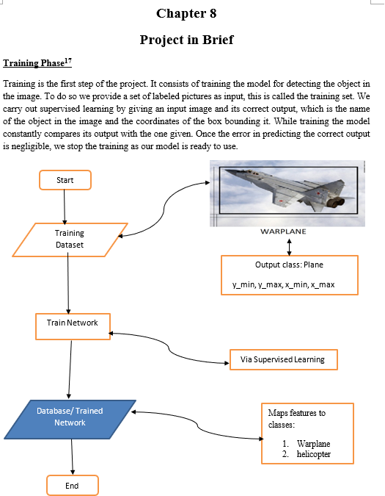

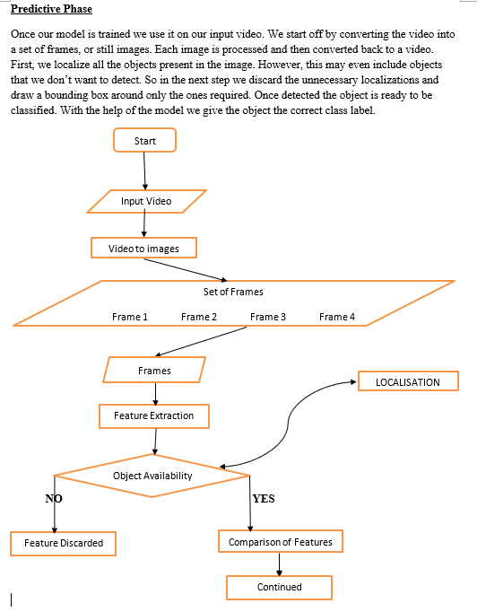
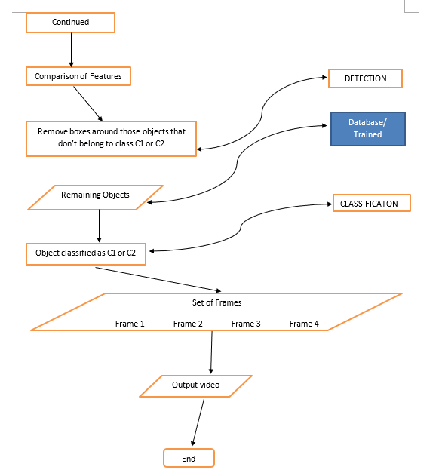

ESOM
Intro : The organisation seeks to spread Economic, Financial and Business literacy among the students, and I have handled the day to day workings of the whole team in the capacity of HR head including and not limited to:
1. Ensuring proper team management.
2. Organising and conducting various workshops related to economics and finance.
3. Connecting the student community to the world of economics and finance.
The club aimed at improving the financial literacy of university students by conducting talks, seminars, and competitions.
In the 3rd year, my stint with Economics Society continued. I got into the society board and I gave multiple talks, conducted sessions with the team ,and handled the internal functioning of the team, day to day activity such as everyone is contributing to the team, what functions to plan next, what to deliver.
Here I learned things about stock market which was later used in Finlatics, where I built and lead the sales and marketing team.
FINLATICS
This role came after my experience in economics society. A Finance Based Startup, Finlatics, which was based out of Mumbai. It was a team of 5 people, and the startup was a virtual simulation of the stock market and it provided real-time experience.
I was the first person to join in the sales and marketing department as Business Development Associate.
My goal with the startup was as product design and sales and marketing role. We partnered with many student partners from different universities to market the product in their universities. Over the period until I left 7 months later, our product was in more than 30 universities in the country and crossed net revenue of 5Lakh rupees.
Our Marketing Strategy was a combination of Push and Pull.
Push – Via social media platforms, Linkedin and Facebook.
Pull – Getting introduced in the economics club of the colleges and creating word of mouth.

S – Segmented students based on interest towards finances
T – Targeted those students who were attending our seminars, talks.
P – That is how we positioned ourselves.
How did you market?
Intro – Introduced in Manipal.
Growth – Growth in other universities
Maturity -
Decline -

And then I used this combination of product design and data engineering, I started my stint at HitWicket.
How we campaigned? GET INTO FACTS?
Delhi University was one of the biggest achievements that we had during my time. We had registrations from around 25-30 colleges, crossing over 1000 registrations. Each product at rs 250.
Payment structure, 10000 + 10 percent of every commission that was going through.
HOW WOULD YOU INVEST?
Lets say your age is 35 years young.
Go to https://www.nseindia.com/official website. Choose which sector you would like to invest in.
Nifty 50, Nifty next 50, Nifty Midcap.
These are usually very good companies and that is why they have been included in these lists.
Follow these stocks, some stocks which are really good you can choose.
If they fall by 10 percent, put your 30 percent.
If they fall by another 10 percent, put 40 percent.
Hold for sometime then and forget it as at long term. Don’t look for the next quarters.
HITWICKET
A mobile Cricket game based startup in Hyderabad. I was in data engineer and product design team where my day to day was to work evaluate data to figure out how to get our users hooked through the insights of data, how to monetize it, how to retain them on the platform.
Build dashboards, and say the story.
1. Analyze large amounts of information to discover trends and patterns
3. Comparing conversion, retention, and monetization metric based on different factors.
4. Visualize and communicate insights in a compelling way to guide product decisions.
Idea:
We were working on the multiplayer game at that time and I noticed that there were no stakes in the game that could hook the players. It was just unidirection growth where bigger teams dominate the smaller teams. So I suggested a Mahabharat inspired concept where we can bet on our cricket game players for the online match and play the match. And month on month downloads increased.

JLL and REAL ESTATE
world leader in real estate services.
Services include
- office leasing
- facilities management inside the office – Operating expense ratio
- asset management
- sales and leasing
- Infrastructure development
Founded – 1783, London, UK
President and CEO– Christian Ulbrich
India Head – Radha Dhir
HR Head – Tanvi Choksi
Revenue – 20 Billion dollars
Income – 500 million dollars
COMPETITORS – CBRE(Revenue of 24 billion) and CUSHMAN & WAKEFIELD (8 billion)
Headquarters – Chicago, Illionis, US – 2nd largest public brokerage firm in the world.
Has offices in 80 countries.
Future outlook
- Commercial office leasing space – Did see a drop at the start of the pandemic, but during the pandemic. Hybrid is here to stay. Companies, especially IT industries would be growing year on year, hence commercial real estate would grown. Our internal report at JLL says that co-working space is bound to grow over 50 million square feet by 2023.
- Creation of new cities and urbanization - Govt looking for housing for all under PM Awas yojna scheme – Will increase urbanisaiton. Residential sectors have taken a huge surge.
- As per Oxford economics, 17 out of 20 fastest growing cities are from India between 2020-2035
- Huge surge in demand from areas such as warehouses and logistics eg for facilitating supplies of e-commerce companies (23% revenue)
- Data Centres – data localization, data nationalist – Increase in smartphones and data consumption in the country, the companies are required to host the data centres within the geographic boundaries of the country. These need specialized building structures where they are housed, where they are located.
- Combining all this, at the moment real estate is growing around 20% compounded annually year on year. In India is around 120 billion dollars, and projected estimate is 650 billion dollars by 2025, and 1 trillion by 2030.
- By 2025, this will contribute 13% to the Indian economy.
- Real estate as an assest will always remain attractive.
What is RERA Act? Real estate Regulatory authority
Came into effect in 2016.
RERA was established to enhance accountability and transparency with respect to housing transactions and real estate.

JLL TECHNOLOGY
CEO – Mihir Shah, Yishai Lerner
Tech company focused on real estate experience of the users.
For example Nobroker for commercial real estate, but also including office management, building of offices, etc
Our ultimate goal is to :
- Leverage technology to increase the value and liquidity of the world's buildings
- Make the whole process transparent and comparable
- Optimize portfolios (since most of the cost is real estate liability),
- enhance workplace experiences, improve space utilization.
One project aims to:
- Build dashboard for the MNC companies to see how their real estate data is being used, and how can they reduce cost.
- cloud-based facilities management

WHAT DOES YOU COMPANY DO?
WHAT DOES YOUR TEAM DO?
Very briefly, our team in part of JLL Technologies. We cater to JLL as inhouse data engineering team.
We write python scripts which gets data from all the offices around the world, streamline it, and build the pipeline for it to display it on the dashboards.
Got recognized for the same for at JLL Ovations award in 2021.
Earlier we used to build table structures manually, load all the structures manually, but I wrote a python code for it to automate the whole process and the work which earlier used to take 1 day is now completed in a couple of hours. And I was awarded for this.
WHAT DO YOU DO?
Role of DataEngineer - My role as data engineer is to create pipeline for data to load from datalake to datawarehouse. We automate the whole process.
We get the data from datalake, write ETL scripts on it, and then load it in datawarehouse. From there, the analytics team picks up the data and builds dashboard on it.
Data engineers are doing statistics, ML, or build other types of algorithms.
And normally data scientist do not involve into the writing scripts to move data from and building dashboards on top of it.
Data Scientist – From the very same data, make a model to have predictive on the basic of past data. For example, based on the growth of our team, can we predict the sales in the for Q2 of 2022?
Finance dashboards:
1. Dashboards based on country, manager wise, month wise
Presently we made dashboard for the finance team for better insights into the data on which region is making bringing in revenue, manager wise, location wise, etc.
All this data leads to better decision making.
Ques: Have you used data in your own life?
- CAT SCORES tracking
- Daily productivity – Came to the conclusion that I am most productive when I wake up early in the morning. For this I used tracker in my phone, tracker in my web browser and generally kept an excel sheet for other activities and data said that I am the most productive when I start the day early morning.
All About DATA
Digitization - Digitization’s purpose is to encode information in computers by converting from analog to digital format. The process mainly deals with recording data that can eventually be used in digital technologies.
Digitalization - Digitalization deals with information processing, or how digitized data can be used to improve workflows through automating existing processes.
Digital transformation - Digital transformation is all about leveraging knowledge and integrating it in all business areas to enhance engagement and create new value. Example of banking industry.
CLOUD Container-as-a-Service
AZURE
Microsoft's public cloud computing platform. It provides a range of cloud services, including compute, analytics, storage and networking.
Cloud computing is the on-demand IT resources over the internet with pay-as-you-go-pricing. Would include computing power, storage, databases, platform to develop and deploy your application.
With cloud computing, you avoid the hassle of getting physical data centres and can just rent these services and return it when you are done with it.
Benefits
- Minimal maintenance on the hardware level
- Cost effective – Purchase necessary hardware, get computing power and it used to be costly. Now you can just rent for these services.
- Scalable
- Platform Agonistic

What is data mining?
Data mining is the process of discovering actionable information from large sets of data. Data mining uses mathematical analysis to derive patterns and trends that exist in data.
Types
- Predictive Data Mining
- Descriptive Data Mining

WHY IS PYTHON FAMOUS?
- Easy to use, and elegant codes
- High level language, so do not have to worry about complex task such as memory management.
- Cross platform – build and run on windows, mac, and linux
- Huge community – When you are stuck there is someone to help
- Large eco-system – Have libraries, tools, it is already done.
- Python is an interpreted programming language i.e. the software present in the computer reads the Python code and gives the instructions to the machine. That's why it has no compiler.
- It is script based
Why was python 3.0 started?
It was designed to rectify fundamental design flaws in the language—the changes required could not be implemented while retaining full backwards compatibility with the 2.x series, which necessitated a new major version number.
The guiding principle of Python 3 was: "reduce feature duplication by removing old ways of doing things".
Wasn’t backward compatible with Pyton 2.X.
Comparison Parameter | Python 2 | Python 3
Variable leakage | The values of global variables do change in Python 2 if they are used inside a for-loop. | The value of variables never changes in Python 3.
Ease of Syntax | Python 2 has more complicated syntax than Python 3. | Python 3 has an easier syntax compared to Python 2.
Libraries | A lot of libraries of Python 2 are not forward compatible. | A lot of libraries are created in Python 3 to be strictly used with Python 3.
Backward compatibility | Python 2 codes can be ported to Python 3 with a lot of effort. | Python 3 is not backward compatible with Python 2.

DATALAKE VS DATAWAREHOUSE
- DATALAKE is centralized repository for structured and unstructured data storage.
- Data lakes could be used to store raw data as is without any structure. Data from multiple sources, which have different structures are dumped into it.
- Can be used for any kind of data dump.
- Can store many types of data such as images, text, files,videos.

- Database are typically structured with defined Schema
- Items are organized as a set of tables with columns and rows.
- Databases are designed to be transactional and analytics cannot be performed on top of it. It is specially designed to run simple queries.
- DATAWAREHOUSE exists on top of several databases and used for business intelligence. It is basically designed to run different complex queries over databases.
- Data warehouse consumes data from all these databases and create a layer optimized to perform data analytics. Basically a repository that consolidates data from all sources in a single central place.
- Data must be structured in a meaningful way for analytics purposes. So it usually takes several iterations and discussions within the team to arrive at the best warehouse design.
- From here the business intelligence tools take up the data and build dashboards on top of it for analytics.
- BIGquery and Snowflake
AZURE DATABRICKS
Hadoop – Gets data from different sources, shuffle it Basically writes in and out of disk storage.. which is going to take a while.
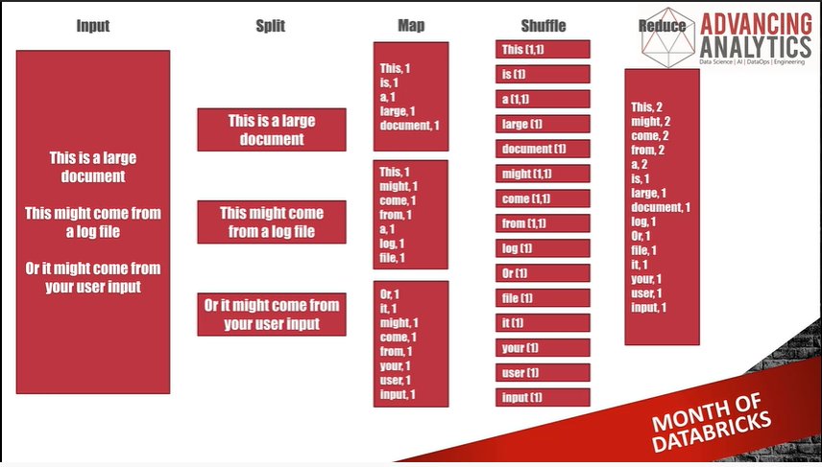
Spark project – Thus idea of spark comes. Taking the idea of MapReduce and Hadoop and this parallel processing, but doing it inside the memory itself.. Thus circumventing a lot of input/output, the disk rewrites, and it can get a lot faster.
Spark is open-source data processing engine built around speed, ease of use, and sophisticated analytics.
DataBricks is meant to be a data science collaborative environment based on Spark. It is this whole management layer around spark, making it really easy to use. Hence basically databricks is wrapped around spark project.
THE Core of databricks is APACHE SPARK. Spark at its core, is doing MapReduce, but doing it in the memory. In Databricks script, essentially a way of writing MapReduce for you.
WHY NOT use Sparks?
If your job is a researcher, you may not want to find out the clusters and what hardwares to use. Hence it makes the job easier for you.
DATABRICKS add
- security control, access control for your team, thus making it easy to use.
- Builds containers for your notebooks
- Job access control – can run automatic jobs

Clusters – are set of machine that are going to set up the process to scale up.
Databricks can handle Dataframes(which I work with), Machine Learning, etc.
Databricks is the management layer build around sparks project to make the whole experience of a developer easy. IT has got workspaces, clusters to run the scripts, tables, etc.
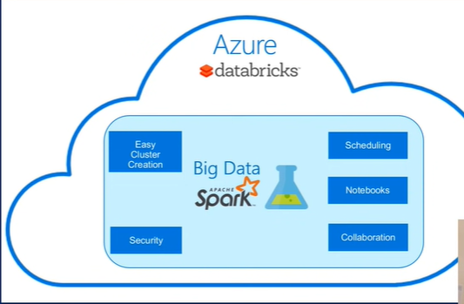
SNOWFLAKE
- Snowflake is a datawarehouse as a service. Don’t need hardware or software to run snowflake since it is cloud based datawarehouse.
- Multi Cluster and shared data – We are able to make use of transient cluster and hence we are able to make it cost effective.
- On demand scaling – can scale up and scale down as per need very easily. Pay as you use.
- Metadata Management – is very easy here and all inbuild within snowflake and we don’t need additional relational database to store metadata and it is all decoupled from the database.
- Time Travel – Can go back and work with dropped tables, although there is a limit to time travel. For standard edition – 1 day. Enterprise edition – 90 days
- Upgrades are happening without any downtime.
- First datawarehouse to Support for semi-structured data. It can understand the semi-structure data very well, it can parse the nested filed and optimize the query plan and ensure that it is leveraging the repeated fields and nested patterns.
- Native Connectors for different technology like Spark, Tableu and Informatica and lot of other technologies.
- Security perspective, it is quite robust.
Architecture of Snowflake:
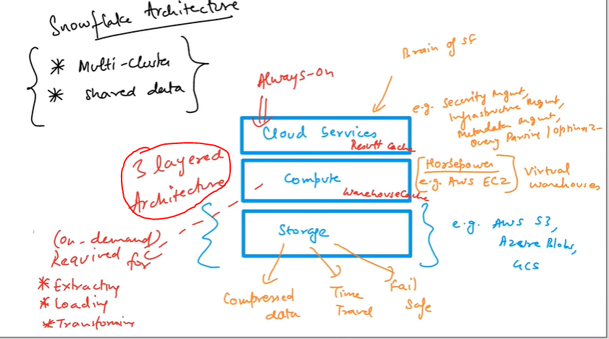

- Cloud Services:
  - Always on, brain of snowflake
  - Security management – can assign roles to different users
  - infrstructre management
  - Meta-data management
  - Query partisioning and optimizing
- Compute Services
  - Virtual warehouse – these are servers.
  - There warehouses can scale up and down on demand, pay per use
  - Max cluster 1-10
- Storage
  - Compressed Data
  - Time Travel data
  - Fail safe
TABLUE DASHBOARDS
Tableau has the first movers account.
Excel in PowerBI in the background.

IMPORTANCE OF DATA
Merge the revolution in info-tech with the revolution of bio-tech, you have the ability to hack humans. KGB can track how I feel, what my systems are.
External systems – can hack all your feelings, emotions, and change it. They can know exactly who you are, better.
What are 5 V's of Big Data?
volume, velocity, variety, veracity and value.
Big Data is unstructured data that exceeds the processing complexity of conventional database systems

Important TECH TOPICS
- CRYPTOCURRENCY
Cryptocurrency is a medium of exchange but in digital format..
Uses encryption technique
- to control and creation of monetary units
- to verify the exchange of money.
In traditional financial dealing which uses fiat money, a central bank is between buyer and seller, act as approver.
In cryptocurrencies, a chain of private computers – constantly work towards authenticating the transactions. Any transaction is being recorded in the democratised model on computers.
SHOULD CRPYTO BE BANNED?
Salvador – Only country to accept BitCoin as legal tender
China – Absolute Ban – Reason because Chinese govt want complete control over the economy. Doesn’t go well with the regime if something is decentralised.
In most of the countries, BitCoin is legal but cannot be used as Legal Tender. In US, Australia it is taxed like real estate.
Negative impacts but the solution to everything is not banning. It needs to be regulated.

Why would people use computing power to solve puzzles?
For solving these mathematical puzzles, these systems are rewarded with cryptocurrencies, and this process is called mining.
At the backend of these transactions is a technology called Blockchain.
- BlockChain
Satoshi Nakamoto – conceptualized the accounting system in the aftermath of 2008 financial crisis.
Created an idea where the transactions and the value of money would be recorded digitally on a publicly available open ledger, where all the transactions ever made would be recorded, although anonymously.
This ledger is called BlockChain
Decentralised – no central authority governing the data.. Technique of storing data on decentralised technique.
Eg – All the transations through the UPI are recorded with the RBI but these cryptocurrencies record aren’t with any central authority but instead on publicly available ledger. But the ledger is encrypted and anonymous.
Cryptocurrencies are essentially codes recorded on a blockchain that gets longer and longer as more people use it.
What is there on each block (3things)?
- Data – Data stored in that bock
- Hash – Unique key to identify that block
- Fingerprint of the previous block
This is how all the data is linked.
- Hence if you try to tamper with any blocks, then the hash will change, which will create a loop effect and whole data will vanish.
- Since it is decentralised, the data copy is saved not with a single authority but a network of authority.
21 million total – 19 million mined
MINERS:
All the computers which allow this blockchain network to run are called Miners. Whenever a new block is added to the chain, these miners ensure that the data is added in the right method.
No 3rd party is needed. Anyone connected to the network can see the transactions in the blockchain.
Security – Every computer on the network has a private key and a public key. Analogy of email address and password.
To make any changes to blockchain, a consensus of 51% is required out of all the computer nodes, making it very difficult to hack it.
Hence more the number of nodes, difficult to hack the environment.

Stablecoin
No base value for cryptocurrencies. Hence, stablecoin comes into picture.
Digital currencies that are backed by a fiat currency such as US dollors, thus giving it an intrinsic value.
Becomes relatively easier to understand.
Govt promote USD coin, Tether and Diem, and it could increase the reach of their fiat currencies in the digital world.
MINING?
HOW MUCH PROCESSING POWER IS REQUIED FOR MINING
- NFT
There can be several NFTs. Just like crptocurrencies.
IN the digital world, no one can claim ownership of copies of a file issued in public domain.
Fungible asset – In economics, Fungible assets are those whose units can be changed. (eg 20rs can be changed into two 10 rs note)
Non-Fungible – Something which cant be changed (Taj mahal, Mona Lisa’s paiting)
NFT – One of a kind digital asset which cannot be exchanged with any other objects. And there is only one original piece, even though there can be pictures which can be shared.
Basically NFTs “tokenise” the artwork and creates digital certificate of ownership, which can be used for purchase and sale.
Digital assets such as art, music, in-game. This is transacted online where maximum transactions is through cryptocurrency.
NFT are encoded with the same software as the cryptocurrencies are encoded with.. They also use blockchain technology where stored data cannot be manipulated with.
NFTs create digital scarcity and the “unique identity codes” make NFTs popular and expensive. Exact opposite of digital creation.
Although screenshots can be taken, the videos can be shard online, but NFT gives them the proof of ownership and for many collectors this digital bragging right is more than the value of the item.
Conclusion
NFTs are being seen as a new revolution in the world market. But they have no past to track performance. It might be the value of digital assets might go down in future.
The prices are being lead only through demand and not on any underlying fundamentals.
Eg – Amitabh Bacchan launching his NFTs for records and clips.

- Metaverse
No official definition, but a rough phenomena of what the people are calling.
First time used in a science fiction novel.
Meta- Beyond, Verse - Universe
A parallel, virtual world where users can have different identities, possessions and characters. An inevitable alternative to reality.
Basically working on the basic human need for bonding and shared experiences.
It is an entirely digital economy, with its own currency and complete parallel world. Games such as GTA 5 already have their own universe inside the universe and it is an extension to that idea.
Disney will create its own metaverse with all the films and streaming services of the movies it owns. You would be able to transport in a world where all the avengers are, or in a world where you get mails from Hogwarts.
Benefits
- Brainstorming sessions will be much more effective, executives all over the world will be able to collaborate and brainstorm the ideas together
- Education will be more interactive, experience
- Paradise of gaming community
Is it safe?
Reports of crimes in metaverse already. A women in US put on her headset to play a game and a guy came and harassed the digital version of her. When asked to stop, the reply was it is the metaverse and I can do whatever I can.
Violent actions in metaverse?
Unsafe for children: Graphic sexual images, racist slurs, extremist views, sexual harassment.
Unhealthy escape from reality : Promises people to give a 2nd life of sorts.
How are privacy safeguarded?
Meta executive said “Policing what people will say in Meta is practically impossible at a meaningful scale”
Conclusion:
- Sensory experiences can’t replace emotions
- Metaverse cannot give us a 2nd life.
- At best it is going to be a imprisoned reality.
Maya-verse from Indian point of view.
- Dapps (Decentralized apps)
Smart contracts between 2 parties where they don’t need a 3rd party(central bank) to create trust. They could just trust the code. They run on blockchain technology and thus they are run over hundreds of thouasands of companies all around the world.
Open Source – Anyone can see and thus builds trust. (We don’t know how facebook recommends us friends or how youtube recommends us videos)
Censorship Resistant – This is good and bad. But good in the financial systems where your money cannot be controlled by the company.
Will never go offline since there is no server downage.
- AI
Father of AI - John McCarthy
AI is a technique which enables machines to mimic human behavior. Or enables the machine to think and take its own decision.
Strong AI – Which are what the sci-fi movies show us. They can act independently in wide areas and mimic the decision making capability of humans.
Weak AI – Which act in a very narrow space. Such as taking a decisions on whether to delete fake movie reviews or not. We can train the ML model to detect pattern between fake and real reviews and then it can take decisions on its own.

We need to harness the energy of the future technology, at the same time minimizing the downsides.
We will see improvement in efficiency, standard of living, since humans would reduce, risk related to humans would reduce.
That is too much into the future. First of all it is impossible that the AI would have an objective to exterminate the humans, they are here to help us. This is just overhyped version of it.
- ML
ML is a subset of AI, and uses stats and data driven solutions to carry out a certain task or make predictions.
Basically it uses algorithm to parse data, learn from data, and make informed decision based on what it has learnt.
Supervised – Train the model from past data
Unsupervised – Based on clustering of data on similarity.. eg K mean clustering.
Reinforced/Semi-supervised – Some part of the data is labelled, and learns slowly from the past data and learns slowly as the new unlabelled data is coming up
- DEEP Learning
Particular kind of machine learning that is inspired by the functionality of our brain cells called neurons which lead to the concept of artificial neural network.
Just that here the features in an image would be found out by the model but if we only have ML, we need to give the features to the ML model.
But overall, Deep Learning is Machine Learning.
Deep learning algo need high end machines like GPUs while ML can work on low end ML models as well.
Deep learning is usually whats behind most human-like artificial intelligence.
ANN – Artificial neural network (for texts, numbers)
CNN – convolutional neural network (for images)
RNN – Recurrent neural network(for time series learning)
- 5G (All Gs in Radio waves spectrum)
It has got high frequency, thus it will cover low distance. - 5G has worked for small distances, and in direct line of site. (Works in the domain of microwave but its power reduces with distance and there is no scientific evidence that it works)
5G has got higher bandwidth – The amount of data being transferred per unit time. Because high frequency allows carrying more data.
High Frequency – Hence can carry more energy, thus more data.

5G needs significant amount of new harmonized mobile spectrum. It has wide variety of spectrum to cover all across the country.
- Prime 5G bands (3.5 Ghz)
- Mid band (1.8Ghz)
- Low Band (700-900Mhz) are also needed to support widespread coverage across urban and rural areas

High speed.
Can be used in smart cars. Cars will talk to each other.
In IOT devices, they will talk to each other.
In expansion of internet.

CELLULAR Wave – Used for cellular waves
FM – 88Mhz – 106Mhz
AM – 100Mhz-200Mhz
Cellular Band – 800-2300Mhz
1G – Only voice – operating on voice only network
2G – 800-900Mhz All the developers were asked to develop there devices bw this.
3G – Till 2100Mhz
4G – Around 2000Mhz frequency band width with decent coverage
Wifi – 2500 to 5000Mhz
How data is transferred over internet?
- Optical fibers are used to transfer internet.
- They are connected to the router. Covert this light signal to electrical signal.
- If it is over mobile, same will happen over cellular towers
- The videos are converted into packets of 0s and 1s. These 0s and 1s are chopped up into packets and send systematically.
Each packet consist of 3 parts:
  - Data
  - IP address of receiver end
  - Sequence number
Each packet takes the best path and does not go sequentially.
We set protocols for transfer of data. Protocols set the rule for data conversion and transfer.
For different applications, the protocols used are different.

- Web 3.0
No official definition, but a rough phenomena of what the people are calling.
Web 1.0 (1991 – 2004) – An intital overview of internet .. Read only, like one big Wikipedia hyperlinked together.
Web 2.0 – (Age of targeted advertising and lack of privacy) Became consumers on internet, in turn companies collected our data to show us better content and started selling the data to private companies. Here, you are the product of the companies.
Web 3.0 – Using blockchain technology and tools of decentralization. Here you are the owner of your content and have full control. For example, your post might be taken down from facebook, but here your post cant be controlled by a single organization.
- The companies will run by DAO (Decentralised autonomous organisation) – which are essentially content creators with the most number of tokens with them. They will get this token when people interact with videos.
- Digital identity wont be 100% connected to your real identity.
Essentially it is a series of ideas that grow together.
Centralised companies such as facebook and google will be disassembled or unreglated DAO’s would replace them.
- Internet of things:
Giant network of connected devices.
Gather data using sensors. This data is sent to a common IOT platform and then how the analytics has been performed, decisions are taken based on it.
- Agile vs Waterfall (used for software development process)
Waterfall is a Liner Life Cycle Model where testing comes after the build phase.
Agile - scrum is a continuous iteration of development and testing in the software development process.
- Industry 4.0
Industry 2.0 – Movement of machine to electrical energy.
Industry 3.0 created automation, and this automation created data.
Industry 4.0 – It means we are in the 4th industrial revolution. Now industry 4.0 is converting this data into insights and take decisions based on these insights. Eg IOT, ML, etc.
IMPORTANT GENRES IN BOOKS
Factfulness: by Hans Rosling
400-420 pages
Humans don’t have enough capabilities that they can absorb and process every information. This leads to biases and instincts.
- This was useful during our early periods, but now we are relatively safer and we have information. We need to try to fix 10 biases to understand the world in a better way.
- Gap Instinct – Law of extremes – All developing countries have poor people.
- Straight line instinct – World Population graph, covid graph
- Fear Instinct
- Single Perspective instinct – Eg poverty is because of Capitalism.
- Blame instinct – Single blame point – Media is baised. Harshad Mehta Scam.
- Size instinct – War on Terror by US. Eg if I give you 4.2 million died in 2016, but 15 million babies died in 1950. Should divide with the base. Thus gives 3 percent and 15 percent out of total people being born.
- Generalization Instict – Stereotypes
- Destiny Instinct – Africa is always going to stay here.
- Urgency Instinct – sales ends in 5 hours on e-commerce sights.
- Negative Instinct – Our negative instincts are triggered way easily than positive ones.
Selfish Gene by Richard Dawkins
Amish Tripathi
Devdutt Patnaik
Yual Noal Harrari

- Indian Mythology
Devdatta Patnaik – Basically trying to differentiate myths from logic. So from a western point of view, most of the cultural practices have been classified as myths, and he is trying to find the logic in every belief that we have. Understanding Indian mythology and simplifying and explain why it is relevant in today’s context.
7 Secrets Shiva – One biggest learning from the book was the concept of -
Dharma – Distributing Value
Artha – Generating value
Kaam – Consuming Value
Moksha – Outgrowing consumption of value and our desire to be valuable. And someone who reaches Moksha is Shiva.
Problems with Devdutt Patnaik:
- Rather than inquiry, Pattanaik presents it as his authoritative interpretation on the books. He did not have the authority for such a gigantic re-interpretation. You can say it is my imagination, but not pass it off as nonfiction and philosophy. The absence of footnotes means that one has to take the writer’s assertions on trust, but Pattanaik’s erudition is generally convincing.
- The second idea of importance in Pattanaik’s books pertains to the notion of karma that is intimately tied to the belief in rebirth. “When one delves deeper (into caste), one notices something very significant. The sages who discussed the caste system were also firm believers in rebirth. Studying caste in isolation, without considering rebirth, creates a myopic understanding of the subject.” The basic building block on which Pattanaik’s argument is constructed is belief in the all-knowing sages of old and the acceptance of their wisdom as superior to the wisdom of the founders of other religions. If one inverts the argument and proposes that rebirth as a notion was invented to perpetuate hierarchy.
- And on twitter there were instances when jus to prove a point he resorted to name calling to women. And that is something which didn’t sit well with me.

In Yogasutra, there is a chapter where Patanjali explains where how by certain meditative practices, one can get this power to extend lifespan of a particular body. For example, pranayama, daily prayer, meditation.
Yoga – Sanskrit word for “unite”
Whos Patanjali? Indian sage, father of yoga, authored a number of Sanskrit texts, most influential were Yogasutras, around 200 BC.
Other traditions : In bible, Noah, Adam crossed 900 years.
The Bhagavad Gita, states that liberation is attained with the help of the mind. It also states that the mind is the best of friends for one who has conquered it, but the greatest enemy to one who fails to do so.
Hinduism?
Some says it is religion, some says it is way of life. It starts as a way of life and develops into religion.
Hindu – Derived from Indus river, called Sindhu. Persians(6th Century BC) know this as Hindus (Hindustan)
More than culture, it was geographical identity.
1830s started calling as Hinduism to differentiate themselves from other groups after soul-searching.
Sanatan Dharam – Eternal religion. Dharam means a set of rules. Snatan Daram – Eternal rules
4 vedas –
- Rigveda – Invite the gods, why? Because they are hungry. Why do we invite? Because we want something. There is transaction. What happens in transaction? Business. And then we have Lakshmi.
- Samveda – Musical knowledge.
- Yajurveda – Yagya gyaan. Exchange between gods and humans.
- Atarvaveda - Medicine knowledge
4 different sects:
- Vaishnava
- Shaiv
- Shakti
- Smartas – worshippers of five supreme beings
4 dhams (Shankaracharya)
- Dwarka,
- Badrinath,
- Jagganath puri
- Sringeri (Rameshwaram)
Avatars of Vishnus:
- Kalki (ends Kayug)
- Buddha
- Krishna
- Ram
- Parshuram
- Narshimha
- Varaha (boar)
- Kurma (turtle)
- Matsya (fish)
Yugs:
- Satya Yug
- Treta Yug
- Dwapar Yug

MAHABHARAT
People Killed – 1.6 Billion
3 Weapons used in Mahabharat.
Vasavi Shakti – Used on Ghatotkacha
Brahmaastra
Pashupatastra
Sudarshan Chakra

- Philosophy
After I failed to join the army, I realized that I was in a limbo. The future was all dark. So I thought, okay, what next?
I realized I did not want to be in this dark space again of not knowing where to go. So I pulled back.
Looked at the bigger picture. Thought on what my purpose in life is.
Earlier I was very focused on the path that I was taking but then I consciously chose the path of looking at the bigger picture.

I wouldn’t be half the person I am today and I would not have developed any understanding of the world.
But I Feel that philosophical texts take years and years to understand and every time you read it, you get a new insight. So it would be foolish of me to say that I have read it.

SOCRATES > Plato > Aristotle > Alexander the great
Philosophy – Love of Wisdom
Branches :
- Metaphysics : Study the nature of reality
- Epistemology – that studies the nature and scope of knowledge
- Value Theory –
- Ethics : How should humans live? Studies and evaluate human conduct
- Aesthetics: Study of beauty
BUT BASIC Idea is not getting too attached to any one kind of Philosophy. IT takes you towards a narrow rabbit hole and then that one philosophy becomes an obsession.
Keep your mind open to other philosophies as well.
MARCUS AURELIUS MEDITATIONS – Most Influential Book
STOICISM – Differentiate between the things you can change and things you cant. And it is important for your well being.
Once you are able to control your emotions and reactions with things which are not under your control, you can pretty much get through anything in your life.
- Ignore what others are doing. Since our time is very limited, and focus on the task on hand. Whatever is our calling on earth.
- Your reality is made by your opinions. You should have a positive light of yourself.
- Do Less – Less superfluous actions, the more importance will those conditions have that are important to us.
- Death is knocking at your door. Do thinks that you are passionate about, don’t waste our time.
- You are tougher than you think. Human mind and body is very adaptable.
- You are rising for the work of humankind. What is your purpose? What is your calling?
- Never Complain. Why should you complain?
- You can live happy anywhere.
- Be grateful for your blessings.
SENECA – HE was aware of the improbability of lasting significance of life.. He believed that life should not be remembered by how long one has lived, but the impact it has made. Life is short, fragile.
Points about Seneca (Letter from a Stoic):
- Heal yourself. The fear of future sufferings, and the recollection of past suffering should be removed from the mind. If we avoid regretting the past and don’t fear the future, we will become indestructible.
- When hungry eat, when tired sleep. Live in the present.
- Seek your own applause. Don’t think about what others are thinking of you.
- Learn the art of contentment. You are poor if you want more.
- Live for others, for the society.
- Boldly face the struggles of life. How we perceive our suffering is far more important than suffering itself.
Taoism - You are not better than anyone else and living with harmony with your surroundings. Not feeling arrogance, for any kind of status. – Remember you are worth something. But at the same time very humble.
Since you are not better than anyone else, you don’t deserve better than anything else and that mindset is very liberating to work towards something
Hinduism Philosophy – You are everything that you see around yourself. We have created this “I” which is defined by the body.. But in reality, this “I” would not even exist without the so called “others” around me. Hence, I and other need each other to survive. Hence, you exist for the world, so much as the world exist for you.

Karmayogi – 4 forms of YOGI
Kantianism vs Utilitarianism –
Kantian – Morality is constant. It applies to everyone equally. We need to ensure that whatever we are doing, it should be applied to everyone.
Eg Batman. You shouldn’t kill, you shouldn’t lie. Absolute.
Utilitarianism – Instead of intent, the outcome of the action justifies morality. Intentions are irrelevant.
- Actions should be measured as pleasure that they produce.
- Greatest good for greatest number of people
Act Utilitarianism – In any situation, you should choose the action that produces greatest good.
Rule Utilitarianism – Follow rules.
- Business Ethics
Business ethics concerns itself with business objectives, techniques and practices used, and the good of the society.
Example:
- Charging fair prices from customers
- Fair competitors for sustainable growth
- Good treatment of workers and earning reasonable profit.
Values : Belief system that guides judgement in situations
Ethics: Well founded standards of right and wrong
Laws: Prescribed by the state as to what should and should not be done.
- Anthropology and Culture
Guns, Germs and steel
Sapiens
- Auto Biographies
Phil Knight – Shoe Dog (Fav book) – What connects me with him is he was able to establish a great company not because he was a born genius, but because he had the ability to persevere. That is what sets him apart. Established the Blue Ribbon Company with Bill Bowerman, his college coach in track and field. And imported shoes from Japan. He opened his first store on the west coast. Since sales from his shoes weren’t enough, he was also teaching at Portland University. and at various stages of his life, he was this close to shutting down the entire company, but just because he persevered, he was able to build what he did. Grow or Die philosophy.
Advice –
- Don’t settle for a job, seek a calling.
- Know when to give up but don’t ever stop.
- Luck may determine your outcome, but the harder you work, the better your luck.
- Have faith in yourself.
Learning – This is the book which made me realise how purpose in life gives your life meaning in difficult situations. And how it is not important what your background is, you are the drive in the right direction, you will achieve your goals.

Hit Refresh – Satya Nadella
a. He was an ordinary boy, and never looked ahead. Always had the present in mind.
b. Both of his kids were challenged, and it made him look towards how tech can help them both.
c. Changed his business from providing tech to Empowering people.

- Political Analysis
- OVERTON WINDOW
The windows on which the public is ready to discuss about.. Both the ideologies want to pull this window towards itself. So they make extreme statements, so that atleast less extreme issues can be discussed.
Eg - gay marriage and rights to animals as humans.
Thus BJP forced other parties to follow soft Hinduism by fielding extreme Hinduism
Right wing shift of Indian ideology - Vajpaee>>Advani>>Modi>>Yogi>>Pragya Thakur
- Parties can win elections in 2 ways:
- Ideological clarity – On the basis of religion, caste, income group, etc. Congress should clarify its ideology. Secularism, economic development, etc. Congress is a centrist party.. Hence they cant win only on ideology.
- Gaining Valency - On the basis of development. Competence, Integrity, Leadership.
- Regional Linguistic Pride - Can work on state level, but cant work on national level.
- How can Congress win?
- Settle its leadership – Need to fix its organisation to convince voters they can solve problem.
- Create model states where it is ruling – eg BJP did from Gujarat
- Create Shadow govt – Show how they would have tackled the issues and share with voters
- Improve Valency image – Talk more about past achievements.

- Why Modi is so Popular
For politicians, there image can be classified on the basis of something called “Telfon-Velcro scale”
- Teflon image - Leaders on whom negativity does not stick at all, and only positive things remain.
- Velcro Image - Leaders on the other extreme of the scale, that when they say anything, the negative image remains on them.
Reasons for Telfon Image:
- Hindu Majoritarinasim - Modi has become spiritual leader as well.. No one doubts the intentions of Modi.
- Benjamin-Franlin Effect – Request favors from people, makes us like them. Shift responsibility towards citizens.
- Nationalism
- Weak Opposition

What latest Movie did you watch?
INTO THE WILD : He wanted to get rid of things in life. He wanted to experience the wild and figure out the true nature of life.
Ultimately he realised, to make life meaningful, you need two things:
- A purpose in life to work towards
- An equal in your life to share the experiences with.

